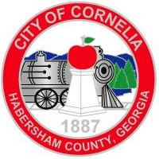

Agenda
City of Cornelia Commission Meeting
January 8, 2019

Call to Order
Invocation
Pledge of Allegiance

- Approval of the Agenda
- Minutes from December 4, 2018 Commission Meeting Tab A
- Minutes from December 19, 2018 Public Hearing Tab B
- Public Forum (Comments will be limited to 3 minutes)
- Employee Longevity Awards
- Resolution for Kailee Misencik Tab C
- Department Head Annual Reports
- City Manager Annual Report Tab D

Old Business
- Ordinance # 12-18-01, Zoning for 420 Historic Hwy 441 Tab E
- Ordinance # 12-18-02, Annexation of 420 Historic Hwy 441 Tab F

Consent Agenda
11. Appointment to the Downtown Development Authority Tab G
12. Community Development Monthly Report Tab H
13. Proclamation for Arbor Day Tab I

New Business
14. Resolution Approving the Urban Redevelopment Plan Tab J
15. Resolution Activating the Urban Redevelopment Agency Tab K
16. Approval of Engineering Firm for CDBG Projects Tab L
17. Adjourn

