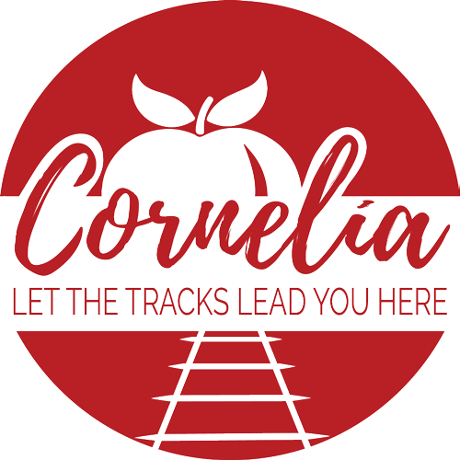

Agenda
City of Cornelia Commission Meeting
December 3, 2019

Invocation and Pledge of Allegiance

Call to Order

- Approval of the Agenda
- Minutes from October 24, 2019 Commission Meeting Tab A
- Minutes from November 5, 2019 Commission Meeting Tab B
- Community Development Monthly Report Tab C
- City Manager’s Monthly Report
- Special Presentation to Barry Trotter
- Employee Longevity Awards
- Public Forum (Comments will be limited to 3 minutes)

Old Business
- None

Public Hearings (City Attorney)
- 2020 CDBG Pre-application Tab D
- 2017 CDBG Project Closeout Tab E
- Multi Family Development At Crown Point Drive Tab F
- Ordinance # 12-19-01, Amendment to Chapter 6 of Zoning Ordinance Tab G
- Ordinance # 12-19-02, Amendment to Chapter 8 of Zoning Ordinance Tab H

Consent Agenda
- Acceptance of the November 5, 2019 Election Results Tab I
- Amendment to Downtown Development Authority Bylaws Tab J
- Commission Meeting Dates for 2020 Tab K
- Budget Adjustment to Increase Line Item 225-54-2010 Tab L

New Business
- Modification to GEFA Loan # CW2017024 Tab M
- Quotes for New Garbage Truck Tab N
- Proposal for Evidence Room and Weapons Room Storage Tab O
- Ordinance # 12-19-03, Brunch Ordinance Tab P
- Executive Session for Personnel
- Adjourn

