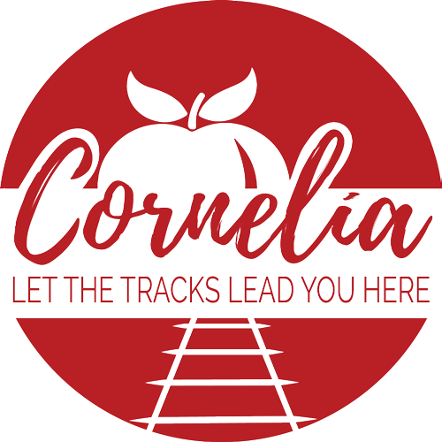

Agenda
City of Cornelia Commission Meeting
July 2, 2019

Invocation and Pledge of Allegiance

Call to Order

- Approval of the Agenda
- Minutes from June 4, 2019 Commission Meeting Tab A
- Minutes from June 17, 2019 Commission Meeting Tab B
- City Manager’s Monthly Report
- Public Forum (Comments will be limited to 3 minutes)

Consent Agenda

- Resolution # 07-19-01, Abandonment of Alley on Wayside Street Tab C
- Water First Memorandum of Agreement Tab D
- Resolution Amending the Urban Redevelopment Plan Tab E

New Business

- Special Events Application from Downtown Development Authority Tab F
- Franchise Fee Agreement with Habersham EMC Tab G
- Grand Avenue-Berry Street Improvements Tab H
- Executive Session for Litigation
- Adjourn

