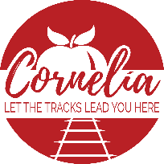
Cornelia Historic Preservation Commission

Thursday, March 16, 2023 3:30 p.m.
Downstairs Administrative Conference Room

- Meeting called to order:
- Approval of agenda:
- New Business
  - COA Application- Casey Martin
  - Downtown businesses-
- Old Business
  - Glass work repairs-Food factory and Borrowed and Blue
  - Food factory-COA Application for window and new paint

- Next Regular Board Meeting: Thursday, April 23 at the Downstairs Administrative Conference Room at 3:30 p.m.

- Adjourn-

Present:

Absent:

